About: A Famous Bubble Tea Company in the Corvallis

Open:

|  |  |
| --- | --- |
| Fri | 12:00–20:00 |
| Sat | 12:00–20:00 |
| Sun | 12:00–21:00 |
| Mon | 12:00–21:00 |
| Tue | 12:00–21:00 |
| Wed | 12:00–21:00 |
| Thru | 12:00–20:00 |

[Passion Fruit Green Tea](javascript:void(0)) $4.71

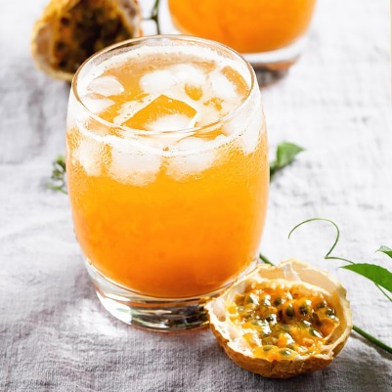

[Hawaii Fruit Tea](javascript:void(0)) $4.71

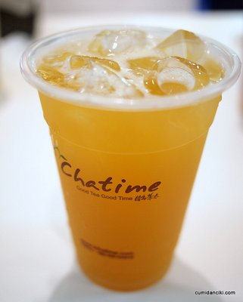

[Large DIY House Special Milk Tea](javascript:void(0)) $5.2



[Large DIY Black Milk Tea](javascript:void(0)) $4.95



[Large DIY Green Milk Tea](javascript:void(0)) $4.95



[Large DIY Brown Rice Milk Tea](javascript:void(0)) $4.95



[Large DIY Thai Tea](javascript:void(0)) $4.95



[Large Oolong Milk Tea](javascript:void(0)) $4.95

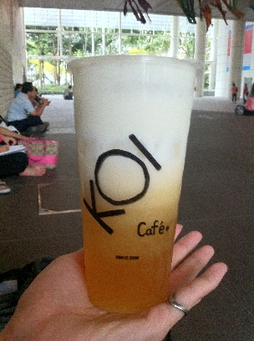

[Large Oolong Tea](javascript:void(0)) $4.21

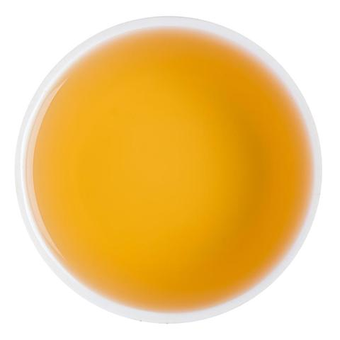

[Roasted Oolong Tea Kreama](javascript:void(0)) $5.2

